Directors of Paata Gugushvili Institute of Economics

Paata Gugushvili

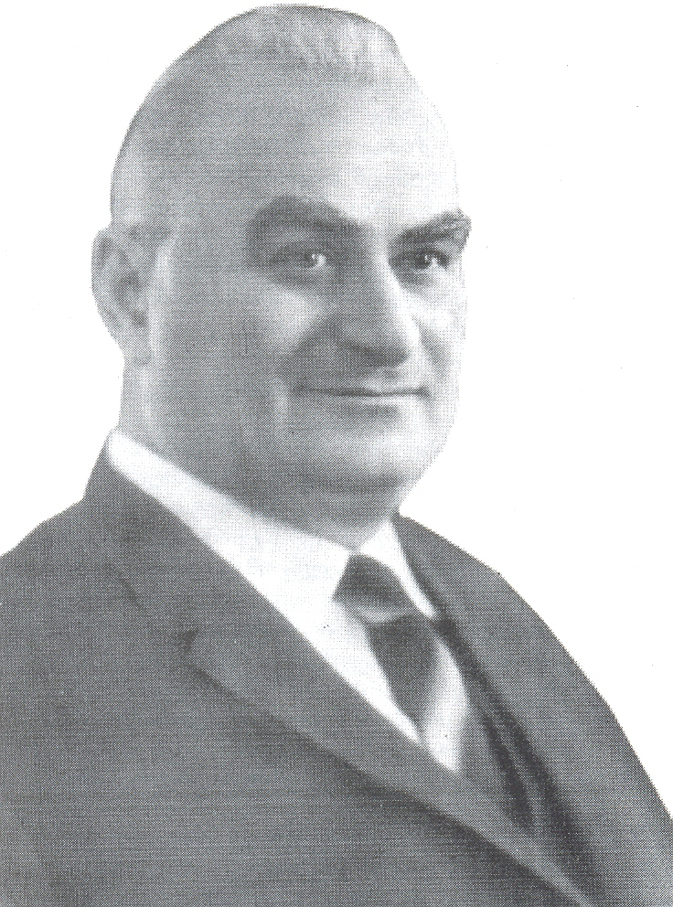

Paata Gugushvili was born on September 28, 1905, village Kodori (Abasha region). He studied at Gymnasiums of Poti and Kutaisi in 1917-1923. In 1923 he continued studying at Tbilisi State University, and graduated the social-economic faculty, specialist of economist-financier in 1927. In 1930 he started working as a teacher at Tbilisi State University. He had been awarded the degree of assistant-professor at the same year and in 1938 with the recommendation of the following Professors P. Gogichaishvili, G. Gekhtman, M. Polievktov, he got the degree of a candidate of economic sciences in 1940, P. Gugushvili maintained a thesis successfully to gain a degree of a doctor of economic sciences. Famous Georgian scientists Iv. Javakhishvili, N. Berdzenishvili and P. Gogichaishvili evaluated his works greatly. In 1940-1945 academician P. Gugushvili was the head of the department of national economy and political economy of Tbilisi State University. During the World War II – 1944, by the initiative of Paata Gugushvili and the decision of relevant organs, the Institute of Economics was founded in the system of the Georgian Academy of Sciences. P. Gugushvili was the head of the Institute for 32 years and in 1948-1974 he was the chairman of specialized scientific council working on doctor’s and candidate’s thesis. In 1961 P. Gugushvili was elected as a corresponding member of the Georgian Academy. P. Gugushvili was a member of editorial group of Georgian magazine ,,Ekonomisti“ in 1930s and 1958, he was an editor of a renewed magazine ,,Sakartvelos Ekonomisti” for 15 years. In 1930-1967 P. Gugushvili productively worked as a scientist and a lecturer at Tbilisi State University as well. Under his guidance more than 100 doctors and candidates are maintained. About 90 qualification works were reviewed and opposed by him. More than 500 scientific works are published and 50 of them are published as separate books. 7 volumes of the monograph ,,Economic Development of Georgia and Caucasus in XIX-XX c.’’ should be mentioned as it represents not only great material about the economic development of Georgia and Caucasus but some economic relations, that had not been noticed by the scientists before, are revealed and analyzed. Academician P. Gugushvili is proved to be a Scientist of great range. An incomplete list of his works refers to the problems of history, journalism, demography and sociology: ,,Georgian book 1629-1929”, ,,Georgian Journalism”, ,,Sociological Etudes”, ,,Population of Georgia During 160 years (1800-1960)”, ,,Issues of Georgian Population Reproduction”, ,,Population, family, children” etc. In 1983 Paata Gugushvili was awarded Honored Prize of Professional Union of Georgia, as a Rector of People’s University of Professional Unions and in1985 – Honored Prize of Presidium of Supreme Council of Georgian SSR. Academician P. Gugushvili died on February 27, 1987.

Avtandil Gunia

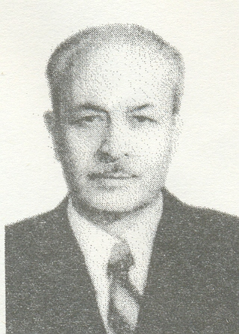

Avtandil Gunia was born on September 27, 1912 in Tbilisi, in the family of workers. In 1928 he graduated from Baku Military Institute. In 1928-1932 he studied at Technical Institute of Railway named after Sh. Eliava in Tbilisi. In 1934 he entered Moscow Institute of Economics and in 1939 he graduated it as an expert in the science of commodities. After graduation of the Institute he was appointed as a director of Trade Technical School in Tbilisi. He was sent to Moscow High School of Party in 1940 and finished it in 1942.
In1942-1952 he worked on different positions in the Central Committee of Soviet Union. In 1952-1953 he was a head of the Department of Polygraph and Publishing at the Ministry Council of Georgia.
In 1953 he was head of the Department of Propaganda and of Central Committee of Georgian Communist Party. In 1953-1957 he was the Minister of Culture of Georgia. In 1957 he was moved as a head of the department of the Institute of Economics of the Academy of Sciences of Georgian SSR. He was deputy director of the Institute from 1960 and director – from 1976. In 1950 and in 1962 he maintained candidate’s and doctor’s degree. He was awarded Professor’s title in 1966.
He was elected as a corresponding member of the Georgian Academy of Sciences in 1967, and from 1979 – as a real member of the Georgian Academy of Sciences.
Avtandil Gunia is the author of more than 160 scientific works, including 20 monographs. Actual problems of economic theory, economy of industry, scientific-technical progress and market economy are described in his works. Among them should be mentioned “Economic Problems of Scientific-Technical Progress of Georgia” (Tbilisi, “Mecniereba”, 1983); “Issues of Formation of Market Relation Mechanism” (Tbilisi, “Metsniereba”, 1991); “Level of Population Living Standard – Factor, Reflecting Economic Development” (Journal “Matsne”, V. I, #1, 1993); “Market (Market Relations as Economic Category)” (Journal “Matsne”, V. I, #1, 1995).
He participated a great deal in bringing up new generations, especially scientific staff, more than 20 candidate’s and doctor’s degrees are maintained under his guidance. He was a head of department of Polytechnic University of Georgia during the years and worked as a lecturer at the same Institute.
Avtandil Gunia’s active work and productivity had been awarded with different state rewards and prizes. He died on October 2, 1997.

Vladimer Papava

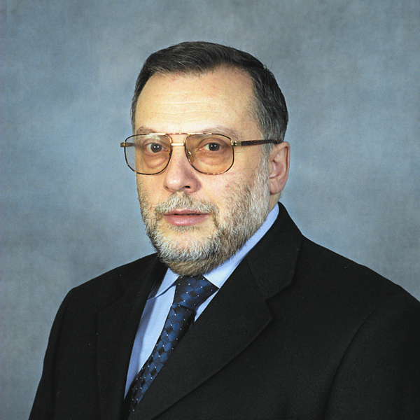
Vladimer Papava was born on April 25, 1955, in Tbilisi, in the family of teachers. He left Tbilisi school #15 successfully (gold medal) in 1972. In 1972 he entered Tbilisi State University, faculty of economic cybernetics, and completed the course successfully in 1977. In 1982 he maintained candidate’s thesis in Moscow (at the Central Economic-Mathematical Institute of the Academy of Sciences of the USSR) and in 1989 – doctor’s thesis.
Vladimer Papava actively participated in scientific, organizational and state activities. In 1991-1996 he was a director of the Institute of Economics named after Paata Gugushvili; 1994-2000 he was Minister of Economy of Georgia; 2004-2008 – a member of parliament of Georgia. Since 1997 he has been a corresponding member of the Academy of Sciences of Georgia.
He is the winner of Republic award of Ministry of Education of Georgia (1987), state award in scientific and technical sphere (2004), and Philipe Gogichaishvili award of National Academy of Sciences of Georgia (2008).
V. Papava is the author of more than 200 scientific works, dedicated to the economic theory, mathematical modeling of economics, microeconomics, post-communist transformation of economy, economic problems of Georgia and Caucasus. Among them are: “Necroeconomics: The Political Economy of Post-Communist Capitalism”. New York: Universe, 2005; “The Political Economy of Post-Communist Capitalism and Georgian Economy.” Tbilisi, PDP, 2002; “Central Caucasus (geopoliteconomic essay)”. Tbilisi, “Siakhle”, 2009.
Under guidance of V. Papava 10 candidates were awarded scientific degrees of economics.
At present Vladimer (Lado) Papava is a senior scientific worker at P. Gugushvili Institute of Economics, senior scientific worker at the Research Fund of Strategy and International Relations of Georgia, Associated senior scientific worker of Politics and Research Transatlantic United Centre, the Central Asia-Caucasus Institute, Jonns Hopkins University (USA).
Vladimer Papava actively participates in public scientific-research and pedagogical activities.

Giorgi Tsereteli

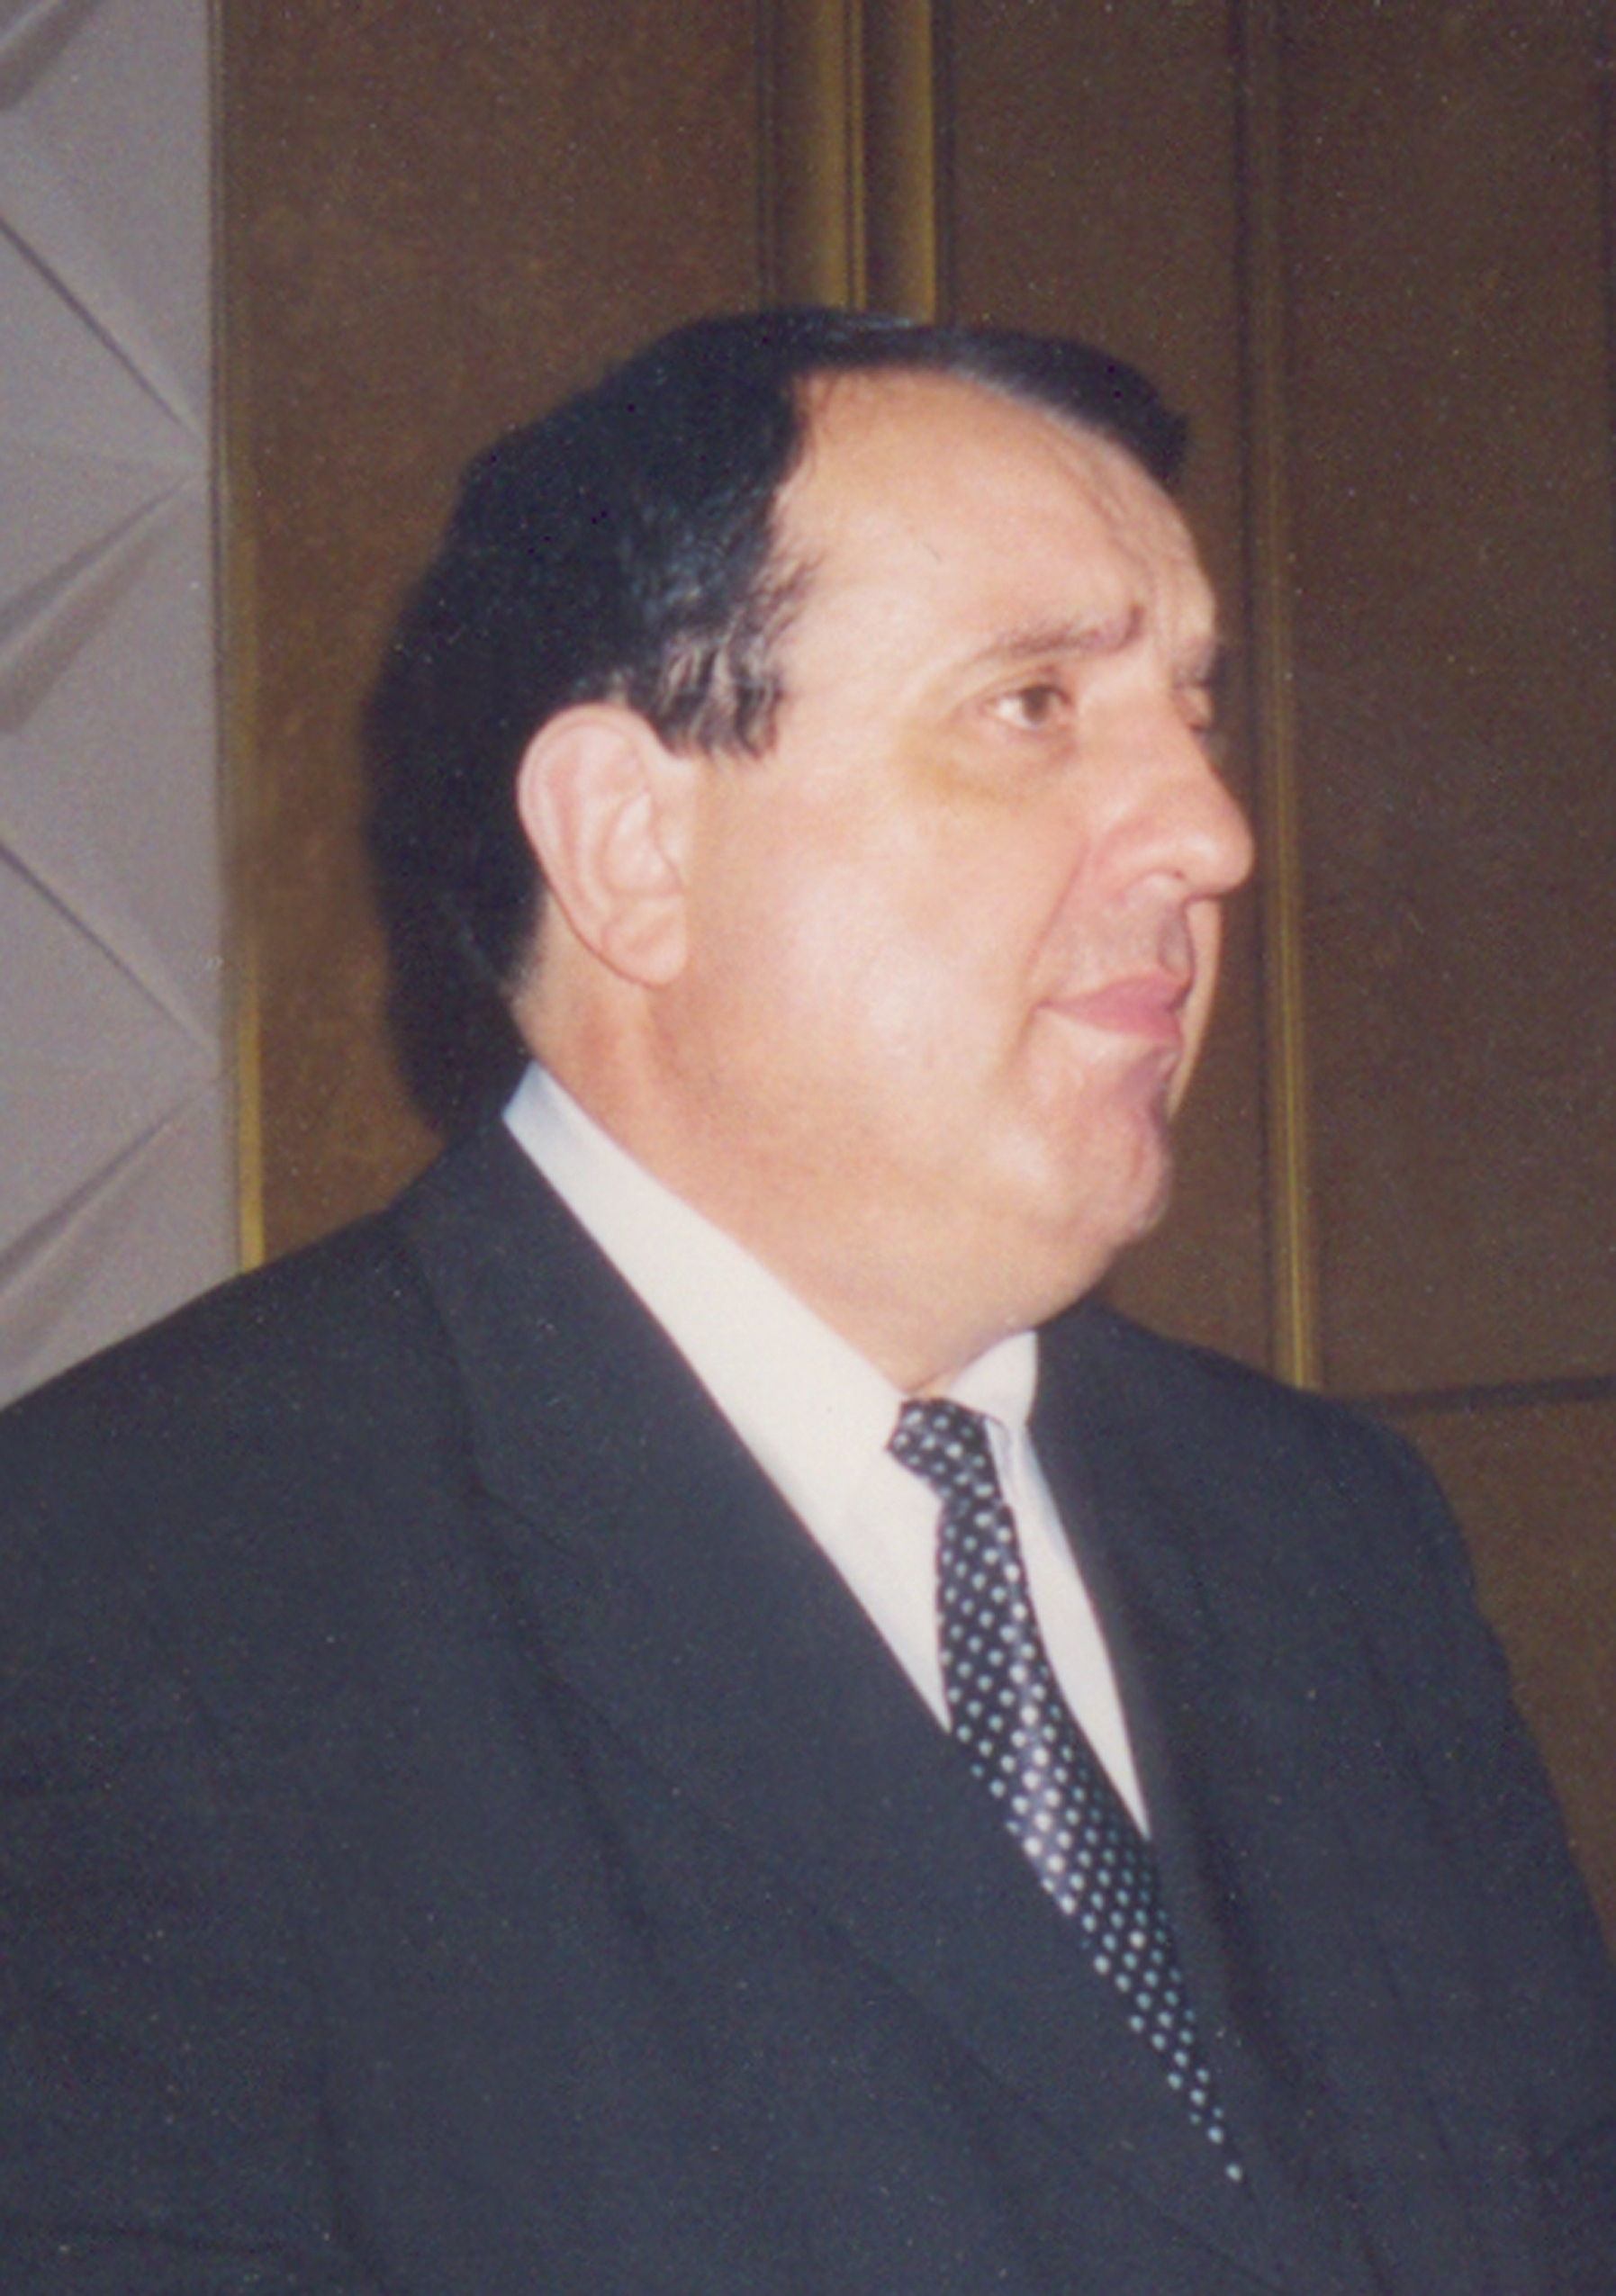

Doctor of Economic Sciences, Professor Giorgi Tsereteli was born on January 20, 1952, in Lanchkhuti. He finished V.M. Komarov School of physics-mathematics in 1969, and in 1975 graduated from Iv. Javakhishvili Tbilisi State University, faculty of Economy. In 1996-2008 he was director of Paata Gugushvili Institute of Economics of the Georgian Academy of Sciences. He worked at P. Gugushvili Institute of Economics as a junior, senior, leading scientific worker, as a deputy director and in 1996-2008 as director (until he died).
He has more than 160 scientific works published. Among them are 20 books (5 co-authorship). One of the monographs – “Economic Issues of Optimization Processes of Use Nature” was awarded a special medal and prize of the Academy of Sciences of Georgia. In 2003 he got state premium in the sphere of science and techniques. Scientific works of Giorgi Tsereteli refer to the research of economic-mathematical, economic-ecological, macroeconomic, economic theory problems.
Giorgi Tsereteli was involved in public activities as well. In 1996-2003 he was a member of Experts Council of Georgia and its economic section. In 1998-2001 he was a deputy chairman of Coordination Council of economics at Experts Council of Georgia. In 1996-2003 he was a member of scientific-consultation councils of Antimonopoly service and Chamber of control, ministries of Economics, Finances, Natural Resources and Environment Protection, Agriculture. From 2000 he was a chairman of the Association of scientists-economists of Georgia till his death. In 2001-2003 he worked as a head of the Scientific Council of the Institute. In 2003-2006 he was a member of the Presidium of the Experts Council of Georgia, from 2004 he till his death was a member of scientific-consultation Council of Economics at President of Georgia.
Giorgi Tsereteli actively participated not only in scientific or organizational work, but also he delivered lectures at Ivane Javakhishvili Tbilisi State University and Technical University of Georgia. He took a great part in preparing highly-qualified staff of our country. Besides, he brought up several generations of student-economists. More than 50 highly-qualified economists were prepared under his guidance, 2 doctors and 5 candidates of sciences. He was awarded the prize of Honor in 2001 for his active participation merit in reforms of economic field and development of economic science of Georgia, for fruitful tutorial and scientific work. Professor Giorgi Tsereteli died on June12, 2008.

Ramaz Abesadze

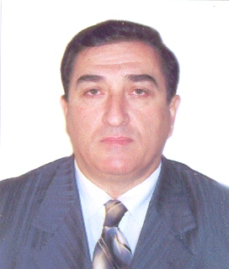

Doctor of Economic Science, Professor Ramaz Abesadze was born on May 14, 1952 in Tbilisi, in the family of teachers. In 1969 after leaving school N54 in Tbilisi, he passed exams at Tbilisi State University, and finished it in 1974 with a qualification of an engineer-economist.
He started working at the Institute of Economics and Law of the Georgian Academy of Sciences. He worked there as a senior laboratory worker (1976), senior scientific worker (1986), leading scientific worker (1989), head of the laboratory (1991), head of the department (1997), deputy director in scientific field (2002), he was elected as director on July 3, 2008.
He was awarded the degrees of candidate of economic sciences in 1985 and doctor of economic sciences in 1999, in 1989 – a degree of senior scientific worker, in 1998 – assistant professor, in 2003 – professors degree with the qualification of macroeconomist. He started teaching in 1987 at Polytechnic Institute of Georgia and then at the Medical Institute. Since 1995 he has worked at macroeconomic department of Iv. Javakhishvili Tbilisi State University. At the same time he is full professor at University of Economics and Law of Georgia.
In 2001-2003 Ramaz Abesadze was a deputy head of dissertation Council at the Institute and in 2003-2007 he was the head of this Council.
He has published more than 80 scientific works, including 6 monographs. Firstly, the subject of his research was economic problem of producing electric energy and its consumption, scientific-technical progress and industrial production. To these problems he dedicated the monograph “Scientific-Technical Progress and the Efficiency of Production and Use of Power in Georgia”, Tbilisi, “Metsniereba”, 1985. Later, the subject of interest of the author becomes problems of using nature and protecting environment. He wrote a monograph on this issue: ”Energy-ecological Factor of Economic Development and Macroeconomic Mechanism of Power Engineering Market Formation in Georgia”, Tbilisi, “Metsniereba”, 2004. At present his scientific research involves economic problems connected with economic development and Post-Communist transformation: “Economic Development” and “Macroeconomic Regulation Mechanism of Small Business in Georgia”. On this base the course of lectures has been prepared for University students of economic department.
Doctor of Economic Sciences, Professor R. Abesadze is the initiator of foundation and editor-in-chief of international-analytical journal “Ekonomisti” and “Collection of scientific works of Paata Gugushvili Institute of Economics”.
Editorial staff was founded with the initiative of R. Abesadze to publish “Big Georgian Economic Encyclopedia”. Besides, he organized various important arrangements at the Institute (such as: foundation of publishing, the study of Academician Paata Gugushvili, discussion room, teaching and consultation-expert centre, scientific prizes, new services etc.)
Professor Ramaz Abesadze was thanked by President of Georgia in 2001 and was awarded the Order of Honor in 2002 for his deeds and active participation in the development of economic science of Georgia.

